KKAT -

Functionality
The system calculates the work in process. The work in process is updated to the product cost collector or manufacturing order under results analysis cost elements.

Scenario

You want to display work in process that you calculated.

Requirements
WIP was calculated.

Menu Path | Accounting → Controlling → Product Cost Controlling → Cost Object Controlling → Product Cost by Period → Period-End Closing → Single Functions: Product Cost Collector → Work in Process → Individual Processing → KKAT - Display
Transaction Code | KKAT

1. Double click on KKAT – Display.

Display Work in Process: Individual Processing

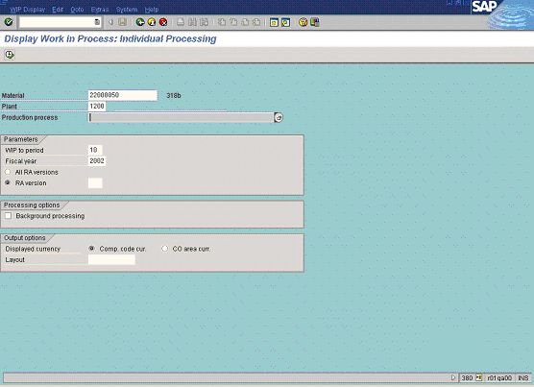

2. Update the following fields:

Field Name | Field Description | Values
Material | Code identifying material number | Example: 22000050
Plant | Code identifying the operational unit of the company where the material is manufactured and stored | Example: 1200

3. Press [F4] or click the Search button in the Production process field.

Choose production processes for material/plant

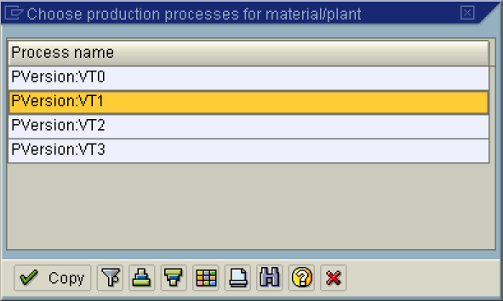

4. Select the Production Version: VT1 in list box.
5. Update the following fields:

Field Name | Field Description | Values
WIP to period | The Period for which WIP was calculated. | Example: 10
Fiscal year | The Fiscal year. | Example: 2002

6. Click the All RA versions radio button.

7. Click the Execute button.

Display Work in Process: Object List

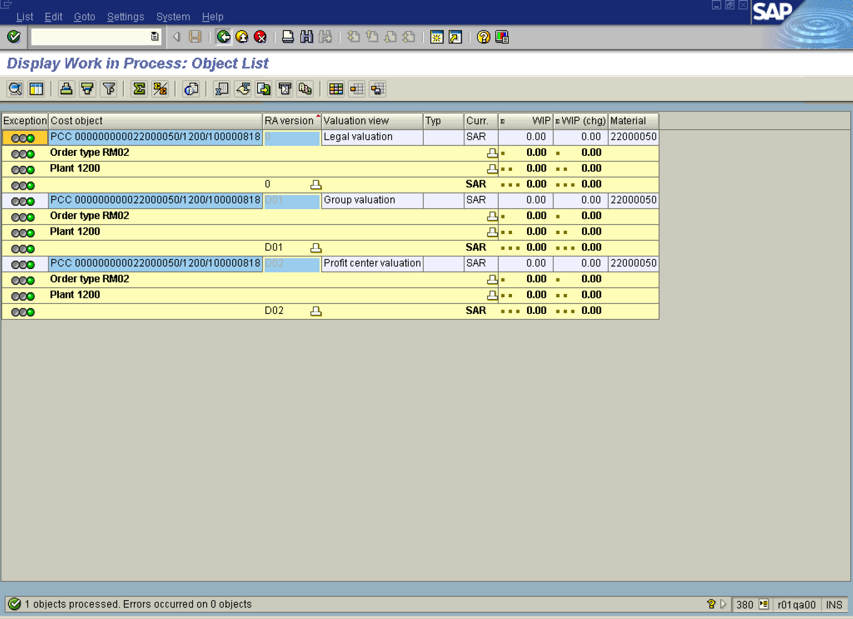

Note: Work in process is displayed per each valuation view, e.g. legal, group and profit center.

8. Click the Back button.

Exit list

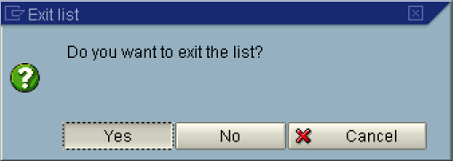

9. Click the Yes button.

